**Unit 2 Notes – Molecules, Compounds and Chemical Equations**

1. **Compound**- two or more atoms combining to form an entirely new substance.

2. **Law of Definite Proportions**- samples of a compound will always contain the same proportion of elements by mass.

Water will always be 1/9 Hydrogen and 8/9 Oxygen. H2O

H = 2( 1) 2/18 = 1/9

O = 1(16) 16/18= 8/9

18g

3. Bonds are how atoms combine to form compounds.

**Chemical bonds**—forces that hold atoms together

**Ionic bonds**-atoms transfer electrons to make compounds. Metals and Nonmetals

**Covalent bonds**—atoms share electrons and make molecules. Two or more Nonmetals

**Chemical formula-** indicates the elements present in the compound and the relative number of atoms or ions of each. Uses symbols and subscripts to represent the composition of the molecule.

*empirical formula* - the *relative* number of atoms of each element in a compound.

*molecular formula*-- the *actual* number of atoms of each element in a molecule of a compound.

Ex. For C4H8 is the molecular formula. The empirical formula is CH2.

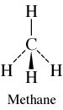 *structural formula*—uses lines to represent covalent bonds and shows how atoms in a molecule are connected or bonded to each other.

H2O O

H H

**Diatomic Elements**- Elements that bond with each other if unbounded to other elements. HOFBrINCl.

4. **Molecular Compounds** are usually composed of two or more covalently bonded nonmetals. The basic units of molecular compounds are molecules composed of the constituent atoms.

Water is composed of H2O molecules.

Dry ice is composed of CO2 molecules.

Propane (often used as a fuel for grills) is composed of C3H8 molecules.

5. **Ionic Compounds** are composed of cations (usually a metal) and anions (usually one or more nonmetals) bound together by ionic bonds. The basic unit of an ionic compound is the formula unit, the smallest, electrically neutral collection of ions.

ionic compound table salt, with the formula unit NaCl, is composed of Na+ and Cl– ions in a one-to-one ratio.

6. **Polyatomic Ions** -many common ionic compounds contain ions that are themselves composed of a group of covalently bonded atoms with an overall charge.

7. **Writing and Naming Compounds**

***Ionic Compounds***

* + Ionic compounds always contain positive and negative ions.
  + In a chemical formula, the sum of the charges of the positive ions (cations) must equal the sum of the charges of the negative ions (anions).
  + The formula of an ionic compound reflects the smallest whole-number ratio of ions.

-- The charges of the representative elements can be predicted from their group numbers.

* The representative elements forms only one type of charge.
* Transition metals tend to form multiple types of charges.
* Hence, their charge cannot be predicted as in the case of most representative elements.

* *Writing Formula for Type I Metals (fixed oxidation number)*
* Write Cation with Charge
* Write Anion along side it with charge.

Al+3 S-2

Al2 S3

* Criss-Cross- drag superscript of the Anion and make it the
* subscript of the Cation.
* Criss-Cross- drag superscript of the Cation and make it the
* subscript of the Anion.
* *Naming Type I Metals*

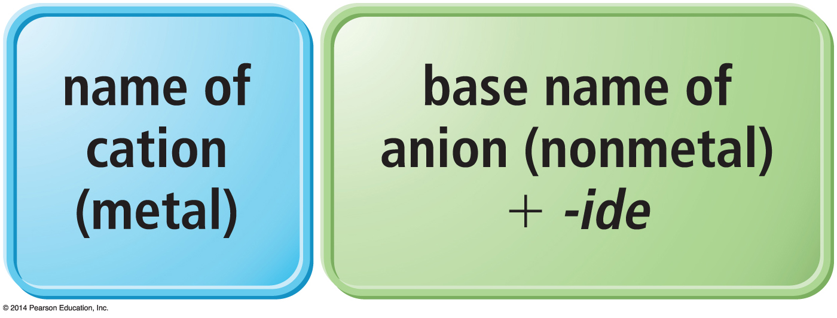

-- *Naming for Type II Metals* ( variable oxidation number all transition metals except AZCA)

-- For these types of metals, the name of the cation is followed by a roman numeral (in parentheses) that indicates the charge of the metal in that particular compound.

For example, we distinguish between Fe2+ and Fe3+ as follows:

Fe2+ Iron(II)

Fe3+ Iron(III)

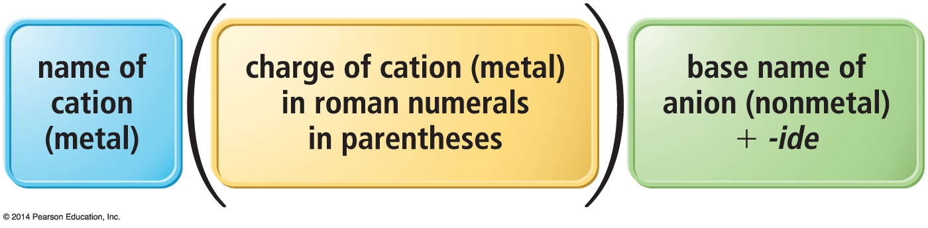

-- *Polyatomic Ions* name the same way as other ionic compounds, except that we use the name of the polyatomic ion whenever it occurs.

***Molecular Compounds***

--Molecular compounds are composed of two or more nonmetals.

--Generally, write the name of the element with the smallest group number first.

--If the two elements lie in the same group, then write the element with the greatest row number first.

--The prefixes given to each element indicate the number of atoms present.

--These prefixes are the same as those used in naming hydrates:

mono = 1 hexa = 6  
 di = 2 hepta = 7  
 tri = 3 octa = 8  
 tetra = 4 nona = 9  
 penta = 5 deca = 10

--If there is only one atom of the *first element* in the formula, the prefix *mono*- is normally omitted.

r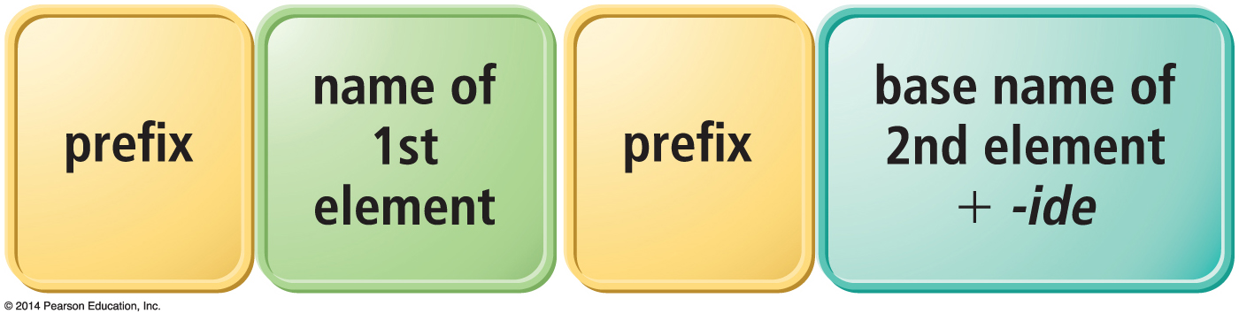

***Acids***

-- generally start with an H.

-- *Binary* acids have H+1 cation and nonmetal anion.

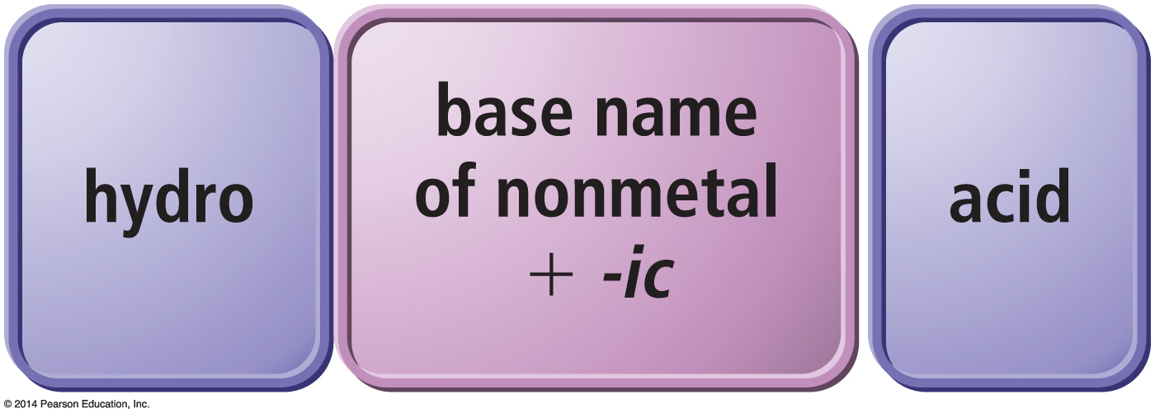

-- Oxyacids have H+ cation and polyatomic anion.

If polyatomic ion name ends in –ate, then change ending to –ic suffix.

If polyatomic ion name ends in –ite, then change ending to –ous suffix.

Write word acid at the end of all names.

|  |  |
| --- | --- |
| **oxyanions ending with -*ate*** |  |
| **oxyanions ending with -*ite*** |  |

